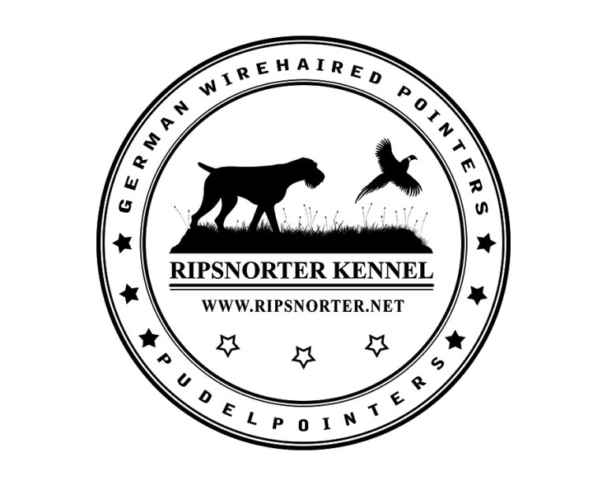
WHAT TO EXPECT IN A RIPSNORTER GWP PUP

- quality pup from health tested parents
- 45 years of top show and hunting lines
- able to leave at 8 weeks old
- up to date on puppy vaccinations/wormings
- registered microchip
- AKC/NAVHDA registered
- 30 days Trupanion Pet Health Insurance

We will ship puppies if needed using United Airlines Pet Safe Program. There will be an additional $500.00 fee which will include shipping, crate, vet
papers and our travel to and from airport.

Our puppies are raised in a family oriented environment. They are handled daily from the minute they are born until they leave for their new homes. At 3 weeks of age puppies are moved to an outdoor puppy pen where they have an indoor heated sleeping area, indoor exercise area and a large outdoor grassy play area. The puppies will be exposed to loud noises (banging bowls, doors and very distant gunfire from other dogs training), a small swimming pool, horses and many different toys. We generally also expose pups to a bird wing before they leave.

Puppies are started on Pro Plan Large Breed Puppy food at 3 weeks old and will be weaned by 7 weeks of age. We take puppies on several walks around the yard and fields each day. Puppies will NOT be crate trained but are generally used to a small sleeping area so a crate is an easy transition.

Our puppies start at $1500.00 and go up to $2000.00 depending on type of breeding. All pups leave on a limited/restricted registration or a co-ownership if it’s a breeding/show pup. The co-ownership will be terminated when owner completes required conformation and hunting titles (CH and JH/NA) and all health testing(CHIC) unless otherwise agreed upon.

We hope that even if you are only purchasing a companion that you will look into NAVHDA. It is a great organization and your new pup can learn a lot from their training. We also highly suggest taking your new dog through an obedience class. Our dogs love being a member of your family. They thrive on spending time with you doing whatever you enjoy. They do need structure, rules and boundaries. If at any time you have questions or concerns, we are here to help you. We hope to continue to get updates from you throughout your pups lifetime.

QUESTIONNAIRE FOR PROSPECTIVE PURCHASERS

This questionnaire is designed to help us make sure that we match you with the dog that best fits your family and your lifestyle. Buying a dog is an investment and serious commitment. We are dedicated to finding our dogs forever homes that care about them as a family member just as much as a show or hunting dog.
Please fill out the following honestly.
If you have any questions at all, please feel free to contact us.

NAME:

ADDRESS:

CITY STATE ZIP:

PHONE #’s:
E-MAIL ADDRESS:

I AM INTERESTED IN: MALE / FEMALE ADULT /PUP

COLOR PREFERENCE: BLACK/WHITE LIVER/WHITE SOLID LIVER

FOR: PET HUNTING SHOW BREEDING OBEDIENCE AGILITY TRACKING NAVHDA

Why are you choosing Ripsnorter Kennel? _________________________________________

_____________________________________________________________________________

Do you intend to acquire titles in any area (show, NAVHDA, hunt, obedience, agility, tracking)? YES NO

FAMILY

Name of Spouse/Companion: ____________________________________________________

Names and Ages of Children:_____________________________________________________

Is there anyone else who will be living with the dog?__________________________________

PET OWNERSHIP EXPERIENCE

Have you previously owned this breed? YES NO

If not, what attracted you to this breed?
___________________________________________________________________

What kind of research have you done on this breed?
_______________________________________________________________

Do you currently have any other pets/animals? YES NO
If yes, what do you have?
___________________________________________________________________

Do you breed dogs now or have you had experience breeding dogs? YES NO
How many litters do you breed per year? __________________________________

Are you interested in breeding this dog? YES NO

Which of the following reasons best fit the primary reason(s) you would like to have a dog? If you mark more than one please put a 1 by the most important and a 2 by the next most important, etc.

COMPANION
PERSONAL HUNTING DOG
FIELD TRIAL/ HUNT TEST/ NAVHDA
CONFORMATION
THERAPY/SERVICE WORK
OBEDIENCE/RALLY/AGILITY
TRACKING
OTHER

TRAINING

Do you believe in crate training a puppy? YES NO

Do you believe in obedience training your dog? YES NO

Do you plan to do hunting training? YES NO

Have you ever trained a dog before in any area before? YES NO

Will you consider attending at least one full session of puppy class and/or beginner
obedience class with this puppy? YES NO

TYPE OF HOME

Do you own your own home? YES NO

If no, does your landlord allow dogs and what size? YES NO ____________________

Landlords contact info for approval:
___________________________________________________________________

FACILITIES AND CARE

WE PREFER OUR DOGS BE IN HOMES WHERE THEY WILL BE ALLOWED IN THE HOUSE TO SOME EXTENT. THESE ARE SOCIAL, COMPANION ANIMALS AND NEED INTERACTION WITH THEIR OWNERS. THESE DOGS THRIVE ON BEING A MEMBER OF THE FAMILY.

How many hours on average per day would the dog be left alone? ___________

WHERE WILL THE DOG /PUPPY BE KEPT?
When someone is home? _____________________________________
When someone is not home?__________________________________

DESCRIPTION OF OUTDOOR AREA FOR THE DOG

FENCED YARD UNFENCED YARD INVISIBLE FENCING

SIZE OF YARD ______________

KENNEL/EXCERCISE AREA (SIZE) __________________
How much exercise are you willing to give to this dog per day?______________

What form of exercise will you provide? (Hiking/Walks/Etc)

ADDITIONAL INFORMATION

What arrangements would you make for the care of the dog if it was unable to travel with you?
___________________________________________________________________________

Is anyone in your family allergic to dogs or dog hair? YES NO

Are you willing to sign a non-breeding agreement? YES NO

Are you willing to give the dog back to the breeder or ask the breeder for assistance if you can no longer care for or keep the dog for any reason? YES NO

Will you agree to always keep the breeder current with regard to your address, and inform the breeder of any problems that may develop with the pup over his/her lifetime? YES NO

VETERINARIAN NAME & PHONE:

Do you have a Veterinarian, or have you contacted one for when the puppy arrives? YES NO

Will you agree to obtain all vaccines and licenses and do all preventative care? YES NO
Do you use heartworm and flea/tick prevention? YES NO

Are you willing and financially able to afford long term or expensive treatment if a situation occurs with your dog? YES NO

Please contact your veterinarian to authorize me to call for a reference.

VETERINARIAN_________________________________________________

ADDRESS_____________________________________________________

PHONE NUMBER________________________________________________

PLEASE BE ADVISED

…IF THE DOG IS SEIZED OR RETURNED BECAUSE YOUR CIRCUMSTANCES TO BE ABLE TO KEEP OR PAY FOR THE DOG HAVE CHANGED, NO REFUND WILL BE PROVIDED. We are always willing to assist in rehoming our pups if needed.

ALL NON SHOW/NON BREEDING DOGS WILL BE SOLD ON A LIMITED REGISTRATION UNLESS SPECIAL AGREEMENT IS MADE BETWEEN SELLER AND BUYER. THIS MEANS THAT IF THE DOG IS BRED THE PUPS CANNOT BE REGISTERED. THE BREEDER CAN CHANGE THIS REGISTRATION AT BUYERS REQUEST UPON MEETING BREEDER REQUIREMENTS. FULLY REGISTERED DOGS WILL BE SOLD ON CO-OWNERSHIP UNTIL TITLES AND HEALTH TESTS ARE COMPLETED. THEN BREEDER WILL SIGN OFF DOG.

CONTRACT AND TERMS AVAILABLE UPON REQUEST

Is there anything you would like us to know that hasn't been covered in this questionnaire?

Do you have any questions you'd like to ask us about our dogs or about dogs in general?

Any other comments or conditions in which you’d like included in the contract?

Thank You for Completing Our Questionnaire!

